**Article 1**

**More people turn to Bitcoin as an inflationary hedge as (monetary) inflation runs hot**

Monetary inflation generally refers to an increase in the broad money supply, such as M2. In other words, it’s not about prices going up; it’s about the amount of money in the financial system going up**.**

Broad money supply refers to various bank deposits for people and businesses as well as other physical currencies in circulation.

The astronomical rise in money supply is charted in the diagram below

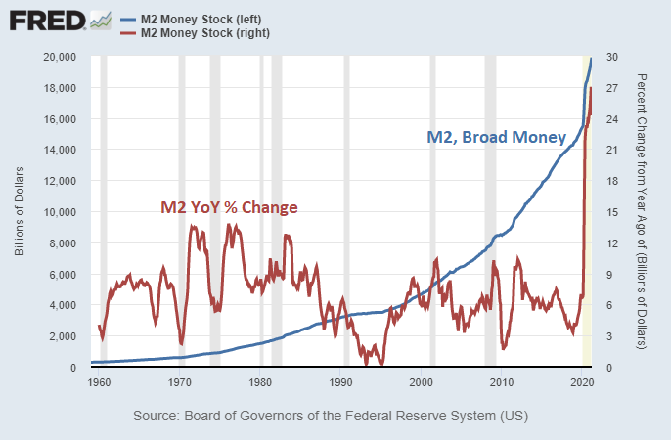

In this chart, the broad money supply (blue) increased from a sum of 15,700 Billion in early 2020 to a towering total of 20,000 Billion in mid-2020. We see that an excess of 4,300 Billion dollars or rather 21% of the total money supply was printed just within the last couple of months.

Consequently, currencies are devalued as a result of monetary inflation, which compels people to buy Bitcoin in order to protect their wealth.

**Article 2**

**As 2021 draws to a close, I’ve collated some key statistics to examine how Bitcoin fared compared to the beginning of the year**

| If you would like to explore the numbers in more detail, feel free to check out my [Powerpoint slide](https://docs.google.com/presentation/d/1o4HKTR1-tZtBjYrJIs-WhZoFOzfT8iUXgle8SkFkvoo/edit?usp=sharing)   * 📈 Prices are up 78.5% from 1-Jan (29k USD) with a current drawdown of 24.4% from 10-Nov ATH (68.56k USD). * 📉 3.7M BTC is currently held at loss, equivalent to 19.5% of the circulating supply. * ⚖️ Overall Exchange balances declined by 2.6 %, with a **net** yearly outflow of 67.8k BTC. * 🔂 Long-Term Holders added 1.846M BTC to their holdings, whilst Short-Term Holder supply declined by 1.428M BTC. * ⏳ Futures **Open Interest** almost doubled, increasing by $9.57B (97%) whilst futures trading **volume** declined by 16% to $36.7B/day. * ⚙️ Mining **hash-rate** fell sharply by 53% in May due to a crackdown in China. But the year concluded with hash rate recovering entirely and even up by 27% * 💵 Meanwhile, aggregate miner **revenue** is up 58% YTD, and up over 440% since in the halving event in May 2020. |
| --- |

**Article 3**

**Why did Ethereum’s Gas Fee rise so much recently?**

Firstly, what are Gas fees

| Gas fees are fees that users pay to node validators, in exchange for their service of validating transactions on the Ethereum blockchain |
| --- |

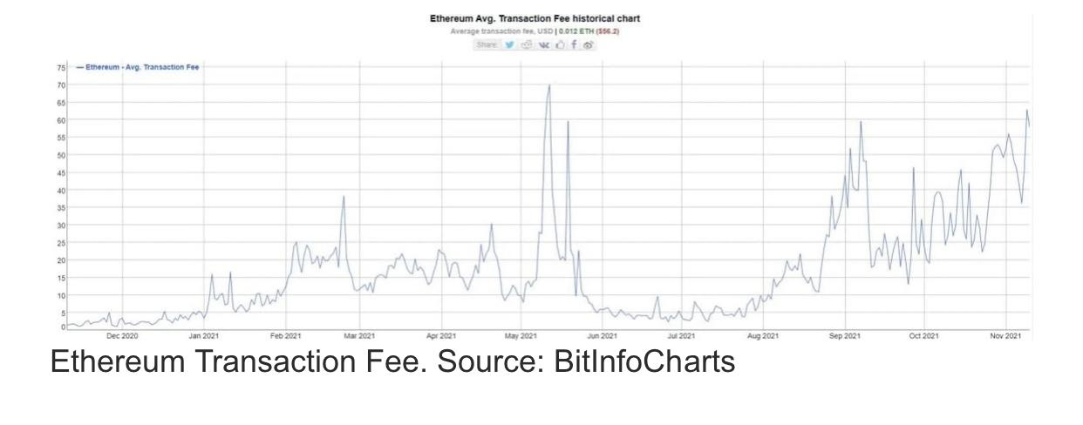

*Graph of Ethereum transaction fees across time*

2 reasons for the increase in Gas fees

Firstly, ETH tokens are burned off as the Ethereum network upgrades

The burning of the ETH tokens is intentional, and its purpose is to make the asset more scarce and valuable. But in the process of making the token more valuable, the Gas fee which is paid in ETH becomes more costly too.

Since the start of the upgrade in August 2021 till November 2021 approximately 848,452.12 ETH has been burned.

*Check out the real-time ETH that has been burned here*

[*Ultrasound mone*y](https://ultrasound.money)

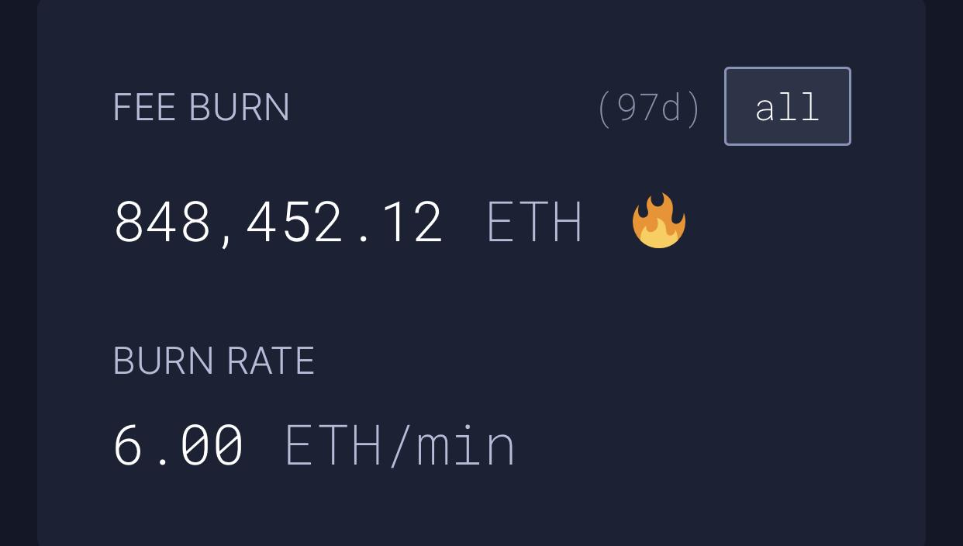

The Second driver of the gas fee is due to the [Ethereum Name Service (ENS)](https://www.google.com/amp/s/cryptopotato.com/ethereum-name-service-airdrops-dao-token-ens-price-up-160-after-launch/%3famp) airdrop launch.

In this launch, every domain holder is entitled to collect free ENS tokens. But the collection of ENS tokens is performed through a transaction in the Ethereum network. Hence, with more people making transactions on the Ethereum network, people have to bid higher Gas fees in order to prioritise their transactions

**Article 4**

**Promising AltCoin projects that seek to disrupt established industries**

* [What Does ETH 2.0 Imply for the DeFi World?](https://www.cryptoknowmics.com/news/what-does-eth-2-0-imply-for-the-defi-world)
* Helium (HNT) building a completely decentralized 5G infrastructure that [seeks to disrupt telecom services](https://www.lightreading.com/5g/could-helium-finally-succeed-where-so-many-others-failed/a/d-id/772271)
* Distributed GPU project Render token (RNDR) building a completely decentralized graphical processing structure [that challenges the biggest cloud vendors](https://www.google.com/amp/s/techcrunch.com/2019/10/02/render-challenges-the-clouds-biggest-vendors-with-cheaper-managed-infrastructure/amp/)
* [Solana-powered Genopets](https://www.google.com/amp/s/cryptoslate.com/solana-powered-genopets-is-redefining-nft-gaming-with-its-move-to-earn-concept/amp/) is redefining NFT gaming, being the first to incorporate the Move-to-Earn concept

Thoughts: The best way of understanding which projects have potential, is asking where has developer interest and whether there is measurable economic activity

## **NFTs**

**Was CryptoPunk #9998 really sold for an extraordinary $532 million?**

No, it was a result of a “wash trading process” where the trader acts as both the buyer and the seller to create an illusion of a price spike. As the market is highly reactive to such news, traders use it to spread FUD and FOMO in the market.

Details of the transaction: A user transferred CryptoPunk #9998 using the address that started from 0xef76. The address of the receiver started from 0x8e39. However, later, 0x8e39 sold that NFT to an address that began from 0x9b5a for a mammoth 124,457 ETH (which was largely loaned). Then the seller later sent 124,457 ETH back to the buyer, who then repaid the loans. Then, the NFT was given back to the address 0xef67. It was then offered for 250,000 ETH to the public

Larva Labs itself said that it intends to remove notifications for these types of transactions in the future to discourage the spread of false information

**How to assess the value and worth of NFTs?**

With the mirage of NFTs available, it is safe to say not all NFTs are valuable.

There are 3 Qualities that can help you choose the right NFT

(1) Rarity & desirability

NFT projects that are **backed by prominent figures/companies are highly tradable/**resellable in the secondary market, especially if it is limited in supply.

(2) Utility

Projects with **utility outside of just being an art piece**. For instance, receiving a physical piece of art that matches the NFT you purchased or exclusive membership with access to events.

(3) Uniqueness

Is the art/project unique, or does it follow the same 8-bit formula as those in the past ?

**NFTs are more than a pet project this year**

This year, we have seen the trading volume of non-fungible tokens (NFTs) surpassing $13 billion, which is a 42,988% increase from 2020

Throughout the year, OpenSea has been the leading marketplace, facilitating 88% of the total volume.

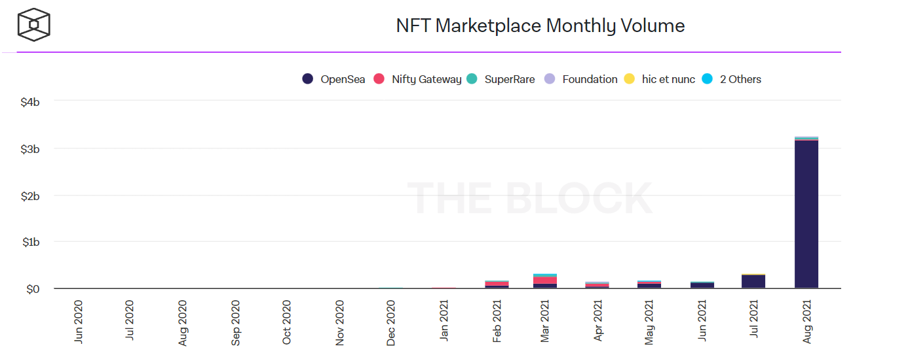

(SOURCE: CRYPTOART, DAPPRADAR)

If you would like to dip your toes into the NFTs sector, I would recommend this [Youtube guide](https://youtu.be/eRYDefnf7jQ) as it is very comprehensive and easy to follow.